|  |
| --- |
| **National University of Computer and Emerging Sciences** |
| In lab 8  “Triggers” |
|  |
| Database Systems Lab |
| Spring 2021 |

Department of Computer Science

FAST-NU, Lahore, Pakistan

# Objectives:

In this lab, students will practice triggers and stored procedures.

# Exercise

Schema is given in Order.sql file

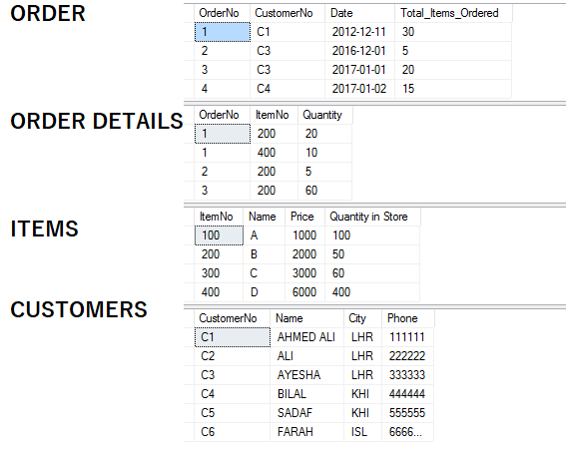

**Note: For Delete Triggers, assume that only one row is deleted in one delete statement.**

1. Create an instead-of-delete trigger which does not allow deleting a customer who has made at least 1 order.
2. Create an instead-of-insert trigger for Order Details which checks whether the quantity in order details is less than or equal to the quantity in store. If the quantity in store is less, simply print some message ‘The required quantity is not available’, and do not insert the record. Otherwise insert the record.
3. Create and after-update trigger for OrderDetails which checks whether the quantity that has been updated for the item is available in the store or not. If not, then rollback the update.
4. Create an after-delete trigger which does not allow deleting any item whose quantity in store is more than 100.
5. Create an instead-of-insert trigger which checks whether the date of the order being inserted is equal to the current date or not. If it is not, simply replacing the date with the current date.
6. Create an after-insert trigger which does not allow inserting a customer whose any of the fields is null.
7. You have to create a customer Signup procedure; it will take all the information of Customer (No, Name City, Phone).

At the end of procedure, it should return a flag (as output parameter) that should tell the violation of following rules:

* 1. Rule1: It should check that the customer No. is unique, so if any existing user has same user number it should return the Flag as 1.
  2. Rule 2: Phone number should be of 6 digits, if it’s less or more it should return the flag as 3.

If both the rules are satisfied then customer should be inserted, and Flag should be returned as 0. Write its Execute Statement as well.